1.Sketch a Simple Prototype of a Bus Ticket Booking System using Figma Tool
Bus Ticket Booking System
Aim
To design and develop a simple interactive Bus Ticket Booking System prototype using Figma, allowing users to search for buses, select a bus and seat, and view the booking confirmation.
Algorithm
- Open Figma and create a new design file.
- Create a mobile frame for the Bus Ticket Booking System.
- Design the Search Bus screen with source, destination, date, and search button.
- Design the Available Buses and Seat Selection screen with bus details, fare, and seat options.
- Design the Booking Confirmation screen with booking details.
- Connect the screens using Figma's Prototype feature.
- Set the appropriate buttons to navigate between screens.
- Run the prototype using Present mode and test the booking flow.

Output:
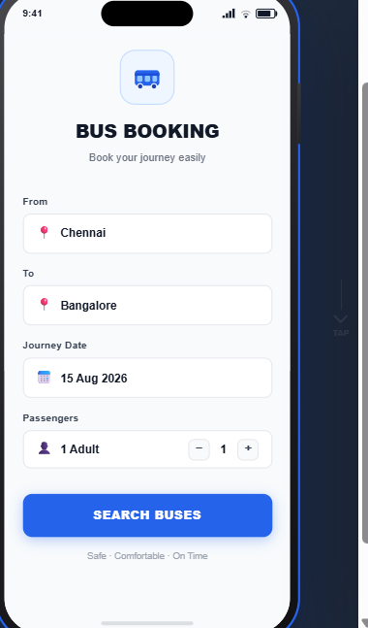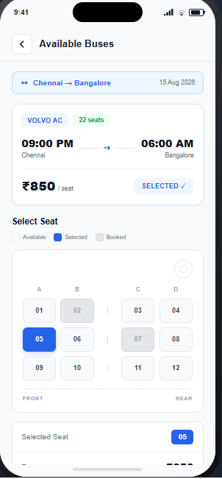

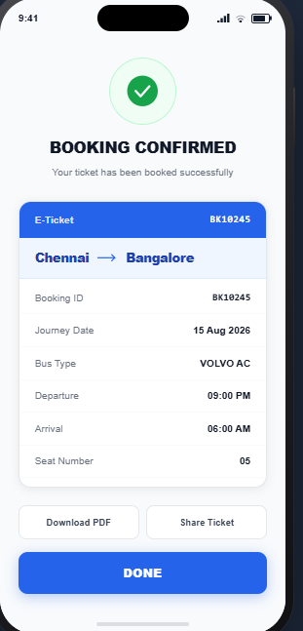

Result
A simple interactive Bus Ticket Booking System prototype was successfully designed in Figma with navigation between the search, seat selection, and booking confirmation screens.

2.The stakeholders have conflicting views on the user interface design for an E-Commerce mobile app. Create a prototype using Figma tool to discuss with the stakeholders to get their feedback and approval.
Aim
To design and develop an interactive E-Commerce mobile application prototype using Figma for presenting the user interface to stakeholders and obtaining their feedback and approval.
Algorithm
- Open Figma and create a new design file.
- Create mobile frames for the E-Commerce application.
- Design the Home screen with search, categories, offers, and products.
- Design the Product Details screen with product information, price, rating, and add-to-cart option.
- Design the Shopping Cart screen with selected products and total price.
- Design the Checkout screen with address, payment method, and order summary.
- Design the Order Confirmation screen.
- Connect all screens using the Prototype feature.
- Set buttons and navigation actions between the screens.
10.Run the prototype in Present mode and demonstrate the complete shopping flow to stakeholders.

OUTPUT:
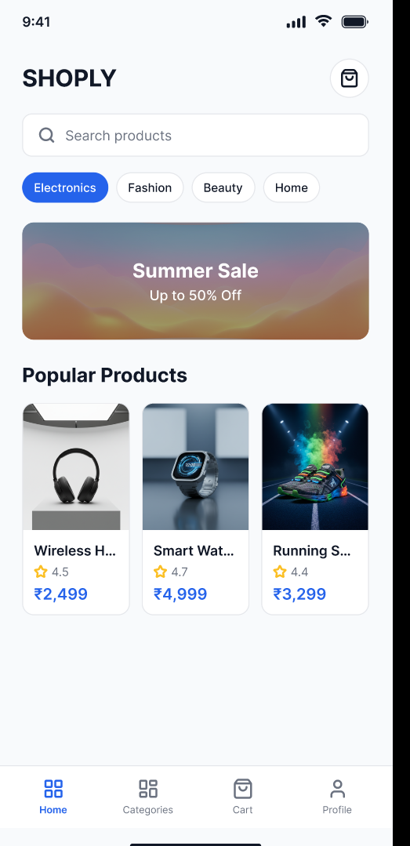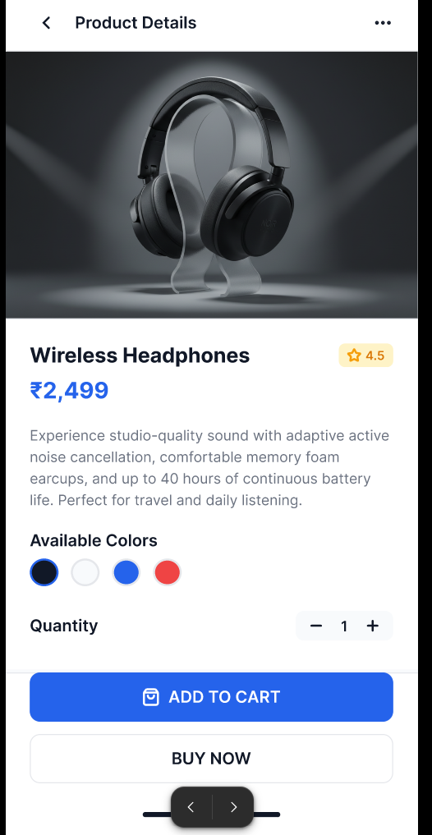

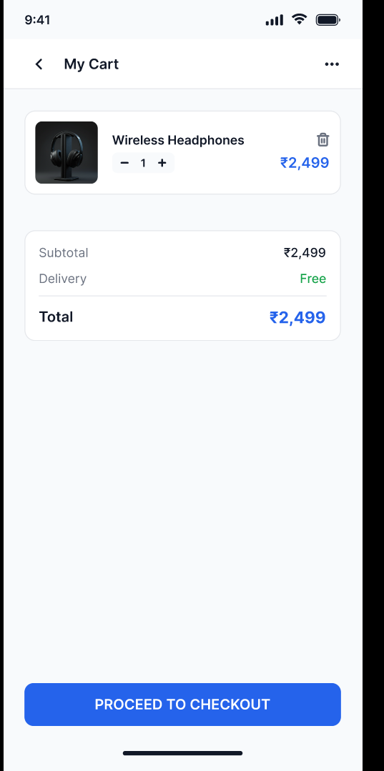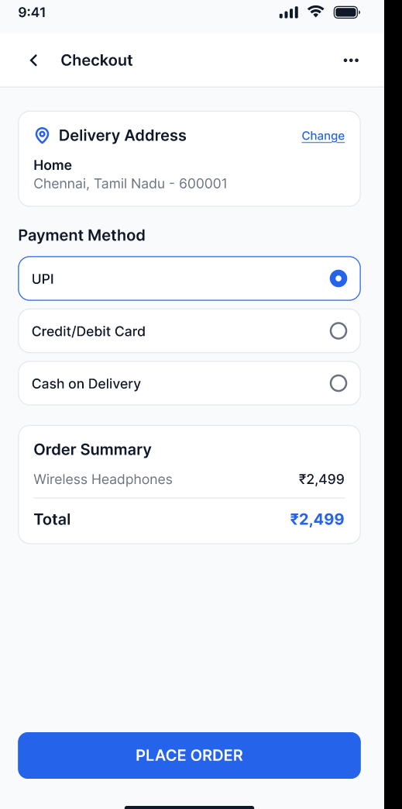
Result
A functional E-Commerce mobile app prototype was successfully created in Figma, demonstrating the complete shopping flow from browsing products to order confirmation for stakeholder review and feedback.

